Metro Ticket Generating System
Project Planning Phase
Work Breakdown, Sprints & Risk Management

ServiceNow Platform | Version 1.0.0 | June 2026
Developed by Nithish Kanna

Introduction
This document outlines the project plan including work breakdown structure, sprint schedule, and risk management for the Metro Ticket Generating System.

Work Breakdown Structure
The project was organized into four sprints across four weeks. Each sprint delivers a working increment of the system.
Sprint | Focus | Duration | Story Points
Sprint 1 | Foundation — Tables, data, schema | Week 1 | 9
Sprint 2 | Core Logic — Business rule, scripts | Week 2 | 10
Sprint 3 | Portal & UI — Service portal, reference config | Week 3 | 9
Sprint 4 | Test & Deploy — Testing, docs, deployment | Week 4 | 12
Total estimated effort: 32 person-hours across 40 story points.

Sprint Burndown
All 40 story points were completed across four sprints with an average velocity of 10 points per sprint. The burndown chart shows consistent progress.
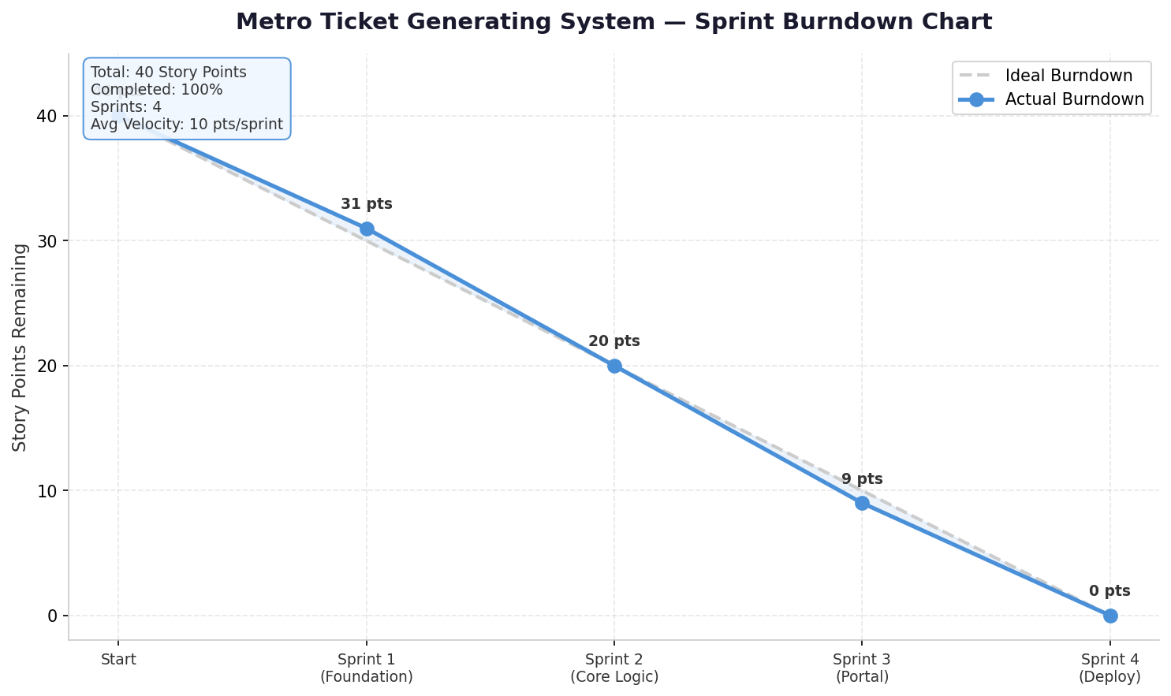
Figure 1: Sprint Burndown Chart

Key Risks & Mitigation
The following risks were identified and managed during the project:
Business Rule Script Errors
Incorrect fare calculations due to script bugs. Mitigated through thorough unit testing with known fare values and gs.info logging for real-time debugging.
Fare Matrix Data Entry Mistakes
Wrong rates or distance brackets entered by admin. Mitigated by double-checking data and creating a validation script.
Update Set Import Failures
Application fails to import on target instance. Mitigated by testing the update set in a clean PDI and documenting all dependencies.

